**Press release**

|  |  |
| --- | --- |
| **New Vintage Art Pop** | **art2o_logo_bereinigt.bmp** |

**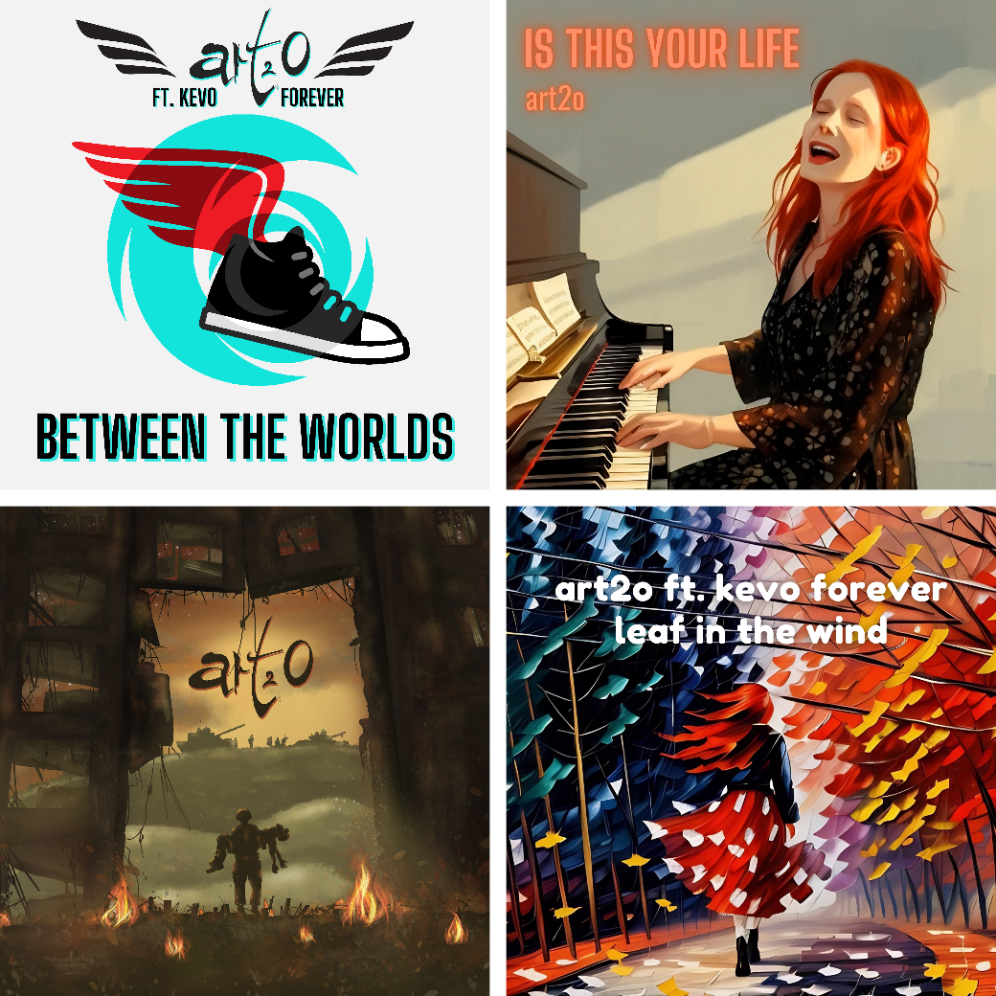**

**Who is art2o?**

**Bandbio**

**Discography**

**etc.**

Content

[art2o versatile and changeable 3](#_Toc174636492)

[The forward development of art2o 3](#_Toc174636493)

[art2o are 4](#_Toc174636494)

[Over 20 years of art2o: Bandbio 4](#_Toc174636495)

[1995 - 1998: The prehistory 4](#_Toc174636496)

[1998 - 2002: The beginnings 4](#_Toc174636497)

[2003 - 2006: The production of the album “Open Eyes” 4](#_Toc174636498)

[2006: The live band breaks up; this disappointment opens up new perspectives 5](#_Toc174636499)

[2007 - 2009: art2o is on the road with the Unplugged program 5](#_Toc174636500)

[2009 - 2012: The creation of the album “Back to Basics” 5](#_Toc174636501)

[2013 - 2014: CD launch “Back to Basics” and further concerts 6](#_Toc174636502)

[2015: Daniela joins the band 6](#_Toc174636503)

[December 2015: Demo CD “Back to Basics Vol. 2” 6](#_Toc174636504)

[2016 and 2017: Consistent further development into an unplugged specialist 6](#_Toc174636505)

[2018: New webpage and anniversary concert – 20 years of art2o 7](#_Toc174636506)

[2019 - 2021: Horizon is created 7](#_Toc174636507)

[2022: Release of Horizon 7](#_Toc174636508)

[2023: People’d Rather Run Than Learn 7](#_Toc174636509)

[2024: A significant increase in the number of releases and a change in the band 8](#_Toc174636510)

[References 9](#_Toc174636511)

[Locations 9](#_Toc174636512)

[art2o is a registered trademark of Schweizer plus GmbH 9](#_Toc174636513)

[Discographie 10](#_Toc174636514)

Digital versions of these pages can be found at:

[**www.art2o.ch**](https://art2o.ch/en/) rubric [**press**](https://art2o.ch/en/us/press-info)

**Imprint**

**Contact**

Thomas Schweizer

Walzmühlestrasse 57

CH-8500 Frauenfeld

+41 76 568 36 21

tschweizer@gmx.ch

**Text / Layout**

Thomas Schweizer

**Photos / Graphics**

Patrick Frischknecht

Cathy Villiger

Thomas Schweizer

Naroa Schweizer

Urs Beyerle

# **art2o versatile and changeable**

In the more than 20 years of its existence, art2o developed from a true rock band to a pop-rock combo to an unplugged specialist. Then, inspired by the production of the album Horizon, the band became increasingly electrified again, turning into an electrified unplugged specialist. This versatility and changeability are now being continued. The longstanding four-piece life combo is disbanding due to the departure of guitarist Lukas and percussionist Daniela. The quartet becomes a duo. However, this is not the end of art2o, but a new beginning. Collabs with other artists are increasingly used to create and release new music, adding further facets to the band's already broad musical spectrum.

Whether original compositions, cover versions or collabs, art2o is characterized by its independence. art2o describes its musical style as **New Vintage Art Pop**.

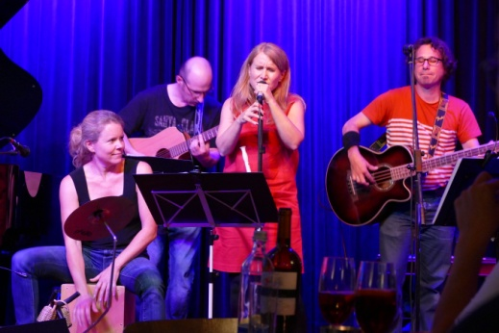 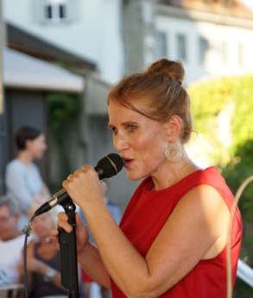 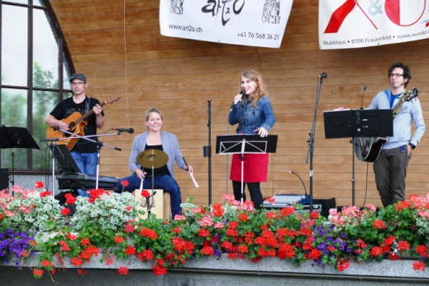

# The forward development of art2o

With the release of the album “**Horizon**” at the beginning of 2022, art2o experienced a significant forward development. At the beginning of this phase, the style description **New Vintage Art Pop** was created for art2o's music. This characterization sums up the band's orientation, which is marked by a modern retro touch. The release strategy was adapted to consumer behavior in a highly digitalized world. In the early years, art2o released an album with a large number of songs on it every few years. Horizon marked a change in this respect. With 6 songs, this EP contained only about half the number of songs on the earlier albums.

The single “**People'd Rather Run Than Learn**” was released in October 2023. This composition was created under the impression of the Russian invasion in the Ukraine. In this song, art2o clearly positions itself against war and points out the dramatic consequences of these senseless actions in our world today.

From this point on, art2o only released singles in order to achieve a sustained presence on streaming platforms. In November 2023, the Christmas song “**Give A Helping Hand**” was released and in December 2023, the LoFi Christmas song “**Christmas Time**” was published in collaboration with Kevo Forever. These so-called collabs (collaborations with other artists) were increasingly integrated into art2o's work. In January 2024, art2o released the song “**Sweetest Depth**”, which was created in a collaboration with Arlay. This was followed in March 2024 by “**Leaf In The Wind**”, the second collab with Kevo Forever. In April, art2o released “**Is This Your Life**”, a quiet number orchestrated exclusively with piano and bass. With “**Finding Hope**”, art2o ventured into new fields in May 2024. Jasmin demonstrated her classical vocal talent to the neoclassical sounds played by Around the World Piano and composed by Athana Siva. This was followed in June 2024 by the remix of the song “**Alive**”, which was realized by Brian Hartbeat. With the third collab with Kevo Forever, art2o once again released a LoFi work “**Between The Worlds**”.

# art2o are

**Jasmin Schweizer** Vocals, Flute, Piano, Kazoo

**Thomas Schweizer** Bass, Ukulele, Cajon, Background Vocals

# Over 20 years of art2o: Bandbio

A long story:

1995 - 1998: The prehistory

When Jasmin and Thomas traveled to LA (USA) to live and work, where they met **Cathi Blum** (later Villiger) and formed a deep friendship, they had no idea that this was the beginning of a long band history. The composer and music producer **Martin Villiger**, Cathi's boyfriend at the time and now husband, heard the song “What's Up” sung by Jasmin during his visit to Cathi in LA. He was thrilled by the powerful and touching interpretation of the 4-non Blondes song, a song that we had long held in our repertoire.

Back in Switzerland, Jasmin and Thomas began composing songs. Over the next two years, they wrote many compositions. 5 of the 14 songs on the album “Open Eyes” date from this time.

1998 - 2002: The beginnings

The band “Atmosphere Priority” is formed around Jasmin, Thomas and Lukas. After producing a CD and a few successful live performances, the band breaks up. Lukas, Jasmin and Thomas decide to continue as a trio. They start composing for the album “**Open Eyes**”. The trio now calls itself **art2o**. The name art2o stands for “**always remain true to oneself**” – the band's motto.

2003 - 2006: The production of the album “Open Eyes”

Martin Villiger is enthusiastic about the music of art2o and decides to produce an album together with the band. The long and fruitful process of pre-production begins, with digital music data being sent back and forth between the trio and Martin, and alternately edited and supplemented. The 14 songs that make up the album “Open Eyes” are created bit by bit.

In addition, the **Pop Up Music & Culture** (PUMC) association was founded on 16.12.2003. From this point on, this association forms the legal framework for the band. All band members become members of the association and art2o is managed as a project of the association.

The songs were recorded in various studios. The album cover was designed by Cathi Villiger, as well as the website of art2o, which was conceived, designed and put online from March to September parallel to the album production.

After “**Open Eyes**” has been produced and manufactured, art2o produces a **video clip** for the song “Perfect”. At the same time, the search for musicians for the live band begins. When the live band is complete, the CD launch is prepared.

The CD launch is a complete success. Around 200 enthusiastic guests celebrate with art2o at the Loft in Frauenfeld. The live performance is recorded by Tele Top and broadcast on 13.04.2006 as part of the Top Events program. Other media also report on the event.

2006: The live band breaks up; this disappointment opens up new perspectives

Disagreements in the live band lead to it breaking up. This is the second time Lukas, Jasmin and Thomas have experienced this. The three of them are alone again! The crisis is seen as an opportunity. An unplugged set is developed, which can be presented live by the trio “without reinforcements”. The program is an interesting mix of original compositions and well-known songs from the pop and rock genres. The cover songs, which are usually not unplugged songs in the original, are given a new and interesting touch by art2o's interpretation.

The first **art2o unplugged** concert takes place at HM-Music in Frauenfeld. It is the beginning of a successful series of concerts.

2007 - 2009: art2o is on the road with the Unplugged program

Motivated by the promising start to the unplugged era, the independent unplugged program is consistently developed further.

Various unplugged concerts followed: Among others, at the first National Fathers' Day in Zurich and at the Eisenwerk in Frauenfeld. They also performed at a wedding ceremony. This performance shows that the unplugged program, which generates exclusively positive feedback, opens up new horizons and also confirms that we are on the right track ...

Numerous unplugged performances are added: e.g. in the Splügenecke in St. Gallen or in the Vinothèque la Trouvaille in Frauenfeld. art2o also perform their unplugged program at the village festival in Dübendorf. Another highlight is a performance at an open-air wedding on the shores of Lake Constance in beautiful weather with an enthusiastic wedding party. It's fun that our program is so well received!

Premiere: art2o unplugged with percussion! At the concert in the Eisenbeiz on 18.10.2008, our friend Tomi Ilg will be joining us for the first time as a percussionist. The art2o project with percussion develops into a series of 6 concerts and is concluded with a performance at the Falken Pup in Frauenfeld on 24.04.2009.

For some time art2o have been thinking about another album and in the summer of 2009, after another performance at the Vinothèque la Trouvaille, they decide to take a break after more than 20 unplugged performances in order to concentrate on their creative work.

2009 - 2012: The creation of the album “Back to Basics”

The band quickly agreed that the new album should have an intimate live character. The listener should feel like the only exclusive guest at an art2o concert. As with the live program, cover versions as well as original songs should be part of the album, with the difference that the majority of the songs should be original.

On the one hand, songs that have already been played live will be reworked and refined. On the other hand, new songs are composed, and two new covers are developed, i.e. they are given the typical art2o polish. The flute, ukulele and harp are instruments not previously used by art2o. art2o decides to produce the songs themselves.

In between, art2o play live on request: e.g. at the confirmation service 2011 in the catholic church in Frauenfeld or at a customer event of a major Swiss bank.

In collaboration with Martin Villiger (friend of the band and producer of art2o's first CD), the final mix and master of the album are created. At the same time, Thomas designs the album cover art and the booklet for the CD.

art2o is deliberately moving at a leisurely pace. On the one hand, the creative process is comparable to the production of a good cheese: it takes time to mature. On the other hand, the trio doesn't always have as much time as they would like for their passion, music, in addition to their family and jobs.

The band has undergone an exciting development from a rock band to an unplugged trio and the musicians are still highly motivated to continue on their varied path together...

2013 - 2014: CD launch “Back to Basics” and further concerts

The revised version of the homepage is now online.

On June 15, 2013, we celebrated the CD launch of the album “Back to Basics” with a live concert at Dreiegg in Frauenfeld. Further concerts followed.

2015: Daniela joins the band

In Switzerland, it is becoming increasingly difficult to perform as a live band. In discussions with musician friends, we realized that it's not just us. Many bands and musicians are unfortunately struggling with the same problem. In this respect, gems like the Essebar in Winterthur, where excellent conditions are offered, as we discovered at our gig on August 29, 2014, are all the more important for us musicians. Even if the conditions in Switzerland are not ideal for musicians, we are far from despondent. Rather, we are making a virtue out of necessity and renewing our program during the involuntary live break. We are also aware that we have advantages as unplugged specialists, because we are versatile, adaptable and convincing on both small and large stages.

Daniela Bättig joined the band as part of this reorientation. The multi-talented musician is an ideal addition to art2o: as a percussionist, pianist and background singer, she is an inspiration for us and brings new drive to our program.

On September 15, 2015, Daniela made her live debut at the 20th anniversary of the Benefo Foundation. The many positive feedback has confirmed our decision to continue on our chosen path. We (the previous art2o band members: Jasmin, Luke and Thomas) are proud of Daniela and her fantastic debut in our band!

December 2015: Demo CD “Back to Basics Vol. 2”

The production of the demo CD “**Back to Basics Vol. 2**” was completed in December 2015. With this CD, art2o documents the new musical momentum that Daniela has brought to the band, in which 7 of the songs produced without percussion are now underpinned with percussion.

2016 and 2017: Consistent further development into an unplugged specialist

Further live performances followed, all generating very positive feedback from the audience, which naturally made us very happy and strengthened our conviction as an unplugged act.

Between performances, the program is always expanded and renewed. The percussion and piano, which became part of art2o's music with the addition of Daniela, open up new possibilities. Furthermore, art2o is increasingly developing a flair for creating art2o-typical versions of cover songs.

Jasmin begins to teach herself to play the piano. These self-taught skills are soon integrated into the band's musical work.

2018: New webpage and anniversary concert – 20 years of art2o

art2o has decided to redesign its website for its 20th anniversary. It is very important to us that the new homepage is responsive, i.e. that it recognizes whether you are accessing the homepage with a PC or a mobile device (cell phone or tablet) and thus optimizes the operation (navigation) and the display for the corresponding device. We also want a very clear and easy-to-use site where we present our music, as this is one of the main messages we want to convey. Of course, a contemporary look is also essential.

The anniversary concert, which took place on 28.09.2018 at the Sound-Industrie in Münchwilen, was awesome! We would especially like to thank our three guest musicians, Martin Villiger, Tomi Ilg and Mutz Barth, who gave the concert and thus our music a very special touch with their dedicated participation. The large audience that came to celebrate our “20th birthday” with us also contributed significantly to the great atmosphere!

2019 - 2021: Horizon is created

The self-taught piano skills increasingly inspired Jasmin and furthered her ability to compose her own songs. Little by little, she wrote numerous new songs, which then matured into finished compositions in collaboration with the others during band rehearsals.

At the end of 2020, driven by the fire of Jasmin and Thomas, the band decided to record 6 of the newly created songs in the studio. It was Jasmin's explicit wish to record the songs under the direction of a female producer. Following a corresponding request from 'Helvetia rockt', art2o came into contact with various women who had the appropriate studio skills. After an evaluation process, the band opted for Anna Murphy and the Soundfarm Studio, which turned out to be the right decision.

While working on the songs to studio maturity, during which our producer Anna Murphy was already accompanying us, the band rediscovered electric instruments such as electric guitar and electric bass at Anna's suggestion on the one hand, and on the other hand the numerous old pieces of equipment available in the Soundfarm Studio such as Rhodes or Wurlitzer offered new possibilities that inspired the band. This is how the band developed a new style, which they call **New Vintage Art Pop**.

After the recordings in summer 2021, the band produced a video for the song Alive. Work on the video was completed at the end of 2021.

2022: Release of Horizon

The release of the album Horizon has been set for 10.02.2022. This is our first purely digital release. So, you can no longer buy a CD, but stream the songs exclusively via the various streaming services or download them as mp3.

For the first time, we started advertising via Facebook and other social media, which slowly increased the number of streams.

We will also be playing a few more concerts in 2022.

2023: People’d Rather Run Than Learn

The year 2023 is characterized by the recording of the songs “**People'd Rather Run Than Learn**” and “**Give A Helping Hand**”.

The composition “**People'd Rather Run Than Learn**” was created under the impression of the Russian invasion in the Ukraine. In this song, art2o clearly positions itself against war and points out the dramatic consequences of these senseless actions in our world today. The song is released in October 2023.

With “**Give A Helping Hand**”, the band realized their long-cherished goal of composing, recording and releasing a Christmas song. The idea behind this song is to combine a traditional vocal melody with modern pop-folk elements, a kind of balancing act between tradition and modernity, which the band has achieved quite well. The song is released in November 2023.

In addition to the recording and production work and getting the releases on track, art2o also played a few concerts in the typical electrified unplugged style.

Almost incidentally, the collab “Christmas Time”, a collaboration with LoFi producer Kevo Forever, is being released in December.

2024: A significant increase in the number of releases and a change in the band

The release of the EP “Horizon” already represented a change in art2o's release strategy. The band realized that consumer behavior in a highly digitalized world had to be taken into consideration. In the early years, art2o released an album with a large number of songs on it every few years. On Horizon, with 6 songs included, the number of songs was reduced to around half the number of the earlier albums.

This change is consistently continued in that the band now only releases singles. This change in strategy has continued unwaveringly since the release of “**People'd Rather Run Than Learn**”. This adjustment in the band's release behavior has led to a relatively constant increase in the number of streams and listeners per month.

Until the beginning of August art2o releases 6 singles:

* **Sweetest Depth** (collab with Arlay), January 2024
* **Leaf In The Wind** (collab with Kevo Forever), March 2024
* **Is This Your Life** (art2o), April 2024
* **Finding Hope** (collab with Around the World Piano), May 2024
* **Alive Remix** (collab with Brian Hartbeat), June 2024
* **Between The Worlds** (collab with Kevo Forever), August 2024

Another obvious change in strategy is the offering of T-shirts in the art2o merch store, each with a design that matches the release.

Daniela Bättig and Lukas Schweizer are leaving the art2o live band at the beginning of July. The quartet, which had existed in an unchanged line-up since 2015, became a duo consisting of Jasmin and Thomas Schweizer. The band now has to reinvent itself in terms of live performance, but not in terms of creativity, as the two driving forces behind the art2o brand (composer Jasmin and co-composer and producer Thomas) will continue to drive the band's success forward.

Due to this change, the Pop Up Music & Culture association is disbanded. The art2o brand is handed over to the company Schweizer plus GmbH, which has been founded in the meantime. Schweizer plus leads art2o into a new future as a registered trademark.

# References

See [us/references](http://us/references) on the homepage www.art2o.ch

# Locations

You can find a list of all art2o concerts from 2006 until today on our homepage.

See [us/live-archiv](https://art2o.ch/en/us/live-archive) www.art2o.ch

# art2o is a registered trademark of Schweizer plus GmbH

art2o is a registered trademark of Schweizer plus GmbH.

© by art2o and Schweizer plus GmbH, all rights reserved.

# Discographie

|  |  |
| --- | --- |
| **Single** | **Between The Worlds** |
| released 2024 | This song is another wonderful collaboration with LoFi producer Kevo Forever. In the lyrics, I describe the many changes I've experienced in my life over the last few months. The longer I walk this path, the closer I get to myself and that's why the light-footed LoFi beat fits perfectly.  Produced by Kevo Forever. |
|  |  |
| **Single** | **Alive Remix** |
| released 2024 | How do I know who I am and what I can do in life? Am I like this because people tell me what I can and cannot do, who I am and who I am not? I feel alive when I listen to myself. This song is about being true to yourself, being authentic and unique. I don't want to just take opinions and attitudes and accept them as universal truth or fact, especially not about myself.  I met DJ Brian Hartbeat on IG and he suggested we do a remix of one of our songs. This remix makes the song ALIVE even more powerful!  Produced by Brian Hartbeat. |
|  |  |
| **Single** | **Finding Hope** |
| released 2024 | Elisa (Around the World Piano), the excellent pianist I met on Instagram, and I thought it would be nice to play a song together. From the many songs Elisa plays, I chose the wonderful composition FINDING HOPE by Athana Siva. I wrote the lyrics, and it was great fun to record this song. This song reminds me of the time when I used to sing musicals. In our world, we can never have enough hope, so I thought Athana's title was so fitting.  Produced by art2o. |
|  |  |
| **Single** | **Is This Your Life** |
| released 2024 | I wrote this song because the topic is on my mind. I often have the feeling that I'm being controlled by others, that life always follows the same pattern. It feels like the autopilot has taken over instead of me taking the wheel and consciously living the life I want.  Produced by art2o. |
|  |  |

|  |  |
| --- | --- |
| **Single** | **Leaf In The Wind** |
| released 2024 | This wonderful lo-fi beat by Kevo Forever has awakened in me the feeling of being in motion, of drifting, of letting things take their course. It just feels so good, so right and so easy, I trust life, the music, myself, everything is in flow. That's what I tried to express in the lyrics. Another great collaboration with Kevo Forever!  Produced by Kevo Forever. |
|  |  |
| **Single** | **Sweetest Depth** |
| released 2024 | This wonderful love song is the result of a great collaboration with Arta Rad (alias Arlay). The groovy beat merges with the polyphonic vocals. Thank you Arta Rad - it was great working with you!  Produced by Arta Rad. |
|  |  |
| **Single** | **Christmas Time** |
| released 2023 | The first collab with LoFi producer Kevo Forever was a very spontaneous idea. The music and vocals were composed within a short space of time. Although this release was not planned, we were very pleased that we were able to release the song on time just before Christmas.  Produced by Kevo Forever. |
|  |  |
| **Single** | **Give A Helping Hand** |
| released 2023 | With “Give A Helping Hand”, the band realized their long-cherished goal of composing, recording and releasing a Christmas song. The idea behind this song is to combine a traditional vocal melody with modern pop-rock-folk elements, a kind of balancing act between tradition and modernity.  Produced by Anna Murphy. |
|  |  |

|  |  |
| --- | --- |
| **Single** | **People’d Rather Run Than Learn** |
| released 2023 | This composition was created under the impression of the Russian invasion in the Ukraine. In this song, art2o clearly positions itself against war and points out the dramatic consequences of these senseless actions in our world today.  Produced by Anna Murphy. |
|  |  |
| **EP** | **Horizon** |
| released 2022  1 Alive  2 The End  3 Dreamworld  4 Sometimes I Fall  5 Where do I go  6 My Way | art2o has once again reinvented itself. In developing their own compositions for this work, they created a new style: New Vintage Art Pop. A modern retro touch marks this production. Original vintage instruments such as the Rhodes or the Wurlitzer were used. Old guitar equipment from the days of the Beatles or the Beach Boys also characterize the sound. A 1960 Fender Precision was used as the bass. This nostalgia is paired with modern arrangements and lots of playfulness. Instruments such as the xylophone and the Schwyzerörgeli complement the rich sound. The intense, touching vocals of Jasmin, which are underpinned by polyphonic backings, are enthroned on top of this. All in all, a playful, intense, versatile and emotional musical experience.  The album was produced by Anna Murphy. |
|  |  |
| **Album** | **Back to Basics Vol. 2** |
| http://www.art2o.ch/wpimages/wpa8ee373b_05_06.jpg  released 2015  1 More than that  2 Open eyes  3 Keep on rocking …  4 Fisherman  5 Momentum  6 One  7 Angels | Basically, the same applies as with “Back to Basics”: reduced to the essentials, this album reflects all the experience of art2o's many unplugged concerts. Now supplemented with the infectious rhythms of Daniela. An ideal completion of our music. This album is produced a little richer than its predecessor, so that the sounds of the percussion can unfold optimally and thus cast a spell over the listener.  Produced by art2o. |
|  |  |

|  |  |
| --- | --- |
| **Album** | **Back to Basics** |
| back-to-baiscs_coverbild.jpg  released 2013  1 Momentum  2 Easy life  3 More than that  4 That’s how things are  5 Keep on rocking …  6 Angels  7 Eager  8 Don’t feel bad  9 Fisherman  10 My true love  11 Open eyes  12 One | This album by art2o reflects the experience of the many unplugged concerts, but also the basic idea of unplugged music: the reduction to the essentials “back to basics”.  According to the band's conviction, the music is completely “handmade”, meaning that not a single electronically generated sound can be heard on the entire album. The production is consistently unplugged. The sound conveys the live character of the music, as if you were standing right in front of the band at that moment and experiencing them live.  “New” sounds have found their way into art2o's music, such as flute, ukulele or harp, instruments that were not yet heard on the previous album. 8 of the 12 songs are original compositions. As always, the strong voice and enchanting vocals of Jasmin are at the center of art2o's music. (art2o has a strict ban on autotune). Stylistically, the songs range from a South Sea touch to unplugged pop and jazz.  The 4 cover versions that complete the album are specifically chosen songs that have either proven themselves live or fit perfectly into the overall picture of the album. There is also a song by the “forgotten” The Havalinas. art2o attaches great importance to ensuring that cover versions always have an art2o touch.  Produced by art2o |
|  |  |
| **Album** | **Open Eyes** |
| coverart2o  released 2005  1 Life  2 Perfect  3 Open eyes  4 Over  5 Fire  6 Losing my youth  7 Inner peace  8 Not wanted  9 Sadness  10 Going to nowhere  11 Gone  12 Where are you now  13 You are my life  14 A little | With their debut album “Open Eyes”, art2o proved that not only musical cheese is produced in the land of chocolate. The musicians impress with their independence and touching depth as well as Jasmin's outstanding vocals. The quality of the production suggests a deep trust between the producer Martin Villiger (martinvilliger.com) and the band.  The songs deal with the road to nowhere, questions about the meaning and nonsense of life, but also the courage to set off. The album testifies to the trio's experience and sensitivity - both lyrically and musically. A passion for music and the will to create something new have resulted in a rich pop-rock album. To describe the music, we let friends and the press speak through quotes: “Alanis Morissette and Kate Bush mixed with a bit of pop” / “The voice reminds me of Tori Amos. I would describe the music as indie rock.” / “Your music is something special. The voice has something of Linda Perry.” / “The style reminds me distantly (and quite positively) of Theater of Tragedy, one of my favorite bands.”  Produced by Martin Villiger |
|  |  |